**CHAPTER 1**

**INTRODUCTION**

* 1. **INDRODUCTION OF THE PROJECT**

The introduction of computers, every aspect of our lives has been revolutionized. When used judiciously, computers can help us save time, secure our personal information, access the required information whenever and wherever required. Keeping all these positive points in mind, we have developed a Movie E-ticketing System where users can book the ticket for movie an online. This application will automate the reservation of tickets and Enquiries about availability of the tickets. Costumer can book tickets for movie according to their conveniences.

**1.2 OBJECTIVE**

The current research aims at reducing the workload over all the entities involved in the ticket counters at movie theatres. The current manual system faces different challenges as to maintaining data manually. Earlier processes of the Ticketing System were obviously not the software ones, but people used to utilize paper forms to track work requests. Since then, the reliability of the internet and mobile technologies have enabled the helpdesk and IT ticketing management system to become more interactive for both requestors and support agents. Many simple and repetitive functions are now available as self-service capabilities. Few benefits of a ticketing management system that you should know and consider:

* Centralized System:

As the ticketing system was organized centrally there is no need of hassles through spreadsheets or email inboxes trying to figure out the issues and their resolution processes.

* Automatic management of tasks:

Using the ticketing system to manage the processes like ticket categorization and prioritization, ticket routing, alerts and notifications, and ticket status management will support the agents to spend more time resolving the actual support issues.

* Better Customer Experience:

It will assist in improving requestors' perceptions for the support experience by troubleshooting the basic steps of agent-assisted support in terms of consistency and transparency along with information, FAQs.

* Enables Prioritization of Work:

The ticketing system enables the requests to get prioritized according to the requirement and difficulty of a query, instead of being handled in the order they are received.

* Drives Staff Accountability and Training:

The ticketing system provides managers with a view into the work of the employees which can help brighten the staff development opportunities.

* In-Built tracking and reporting:

The data created by the software helps to drive the resourcing decisions, process improvement and enable the tuning of support processes to increase customer satisfaction.

Ticketing Management System assists you to find issues and analyze those more, identifying the root causes of problems that may affect your business productivity. The system enables to capture and management requests in a consistent manner so that the authorities can pay more attention to solving issues.

**1.3 PROJECT SCOPE**

The practical implementation of a real time database management system made us understand the intricacies involved in designing the database schema with inter related constraints and the complexity that exists in integrating the front-end system with the back-end data-store.

This project gave us a hands-on experience on developing the entire project using MySQL, and PHP using the Apache Server. We learnt several ways to optimize when designing the database and made quick and rational decisions when developing the project by implementing the procedures taught in class. We could clearly identify the balance we had to maintain when choosing between efficiency and performance.

**1.4 OVERALL DESCRIPTION**

In Movie E-Ticketing System, we use PHP and MySQL Database. This project keeps the records of movies in different screens, booking details etc. Movie E-Ticketing System has two modules that is Admin and User.

**Admin**

Admin is the super user of the website who can manage everything on the website. Admin can login through the login key

**Admin Features**

* Admin can change movies in various screens
* Admin manages bookings
* Admin can Delete and Reset Password
* Manage booking History (Print the details)
* Admin can also update the page content
* Admin can update the contact us details
* Manage Customers
* Admin Dashboard
* Logout

**Customer Registration**

Anyone can register through the signup page. After a successful registration user can log in with valid email and password. User can recover own password by providing some registered info.

**After successful login user can do the following things–**

* View Movies
* Book Tickets
* View Bookings
* Check Credits
* Print Booked tickets
* Logout

**1.5 OPERATING ENVIRONMENT:** WINDOWS 10

Design and implementation constraints

* + Should have a reliable server to handle the expected traffic and privacy.
  + A well designed and maintained backend i.e., database is very important

**1.6 ASSUMPTION AND DEPENDENCIES**

**Assumption**

* + - * System user must have their own server.
      * All the computer user is network.

**Dependencies**

Open-source software

* + - * Visual Studio Code
      * Server: XAMPP/WAMP/MAMP/LAMP (anyone)

**Guideline**

Coding is taken high care to be kept simple and efficient so that further customization and updating possible in near future

**1.7 EXTERNAL INTERFACE REQUIREMENTS**

**User interfaces**

* System should provide all the necessary information at the same time to maintain efficiency and not overload pages with information.
* Each page must be interconnected should have navigation identifiers to indicate the current page user is in.
* Different users logging is must be known and a database of the user logged in must be maintained.
* All the error messages should contain the cause of error and description of error messages.

**Software interface**

Connection to share resources like database should be done using the library provided in the core of the system, also each module can have its own library function which are specific to that module.

**1.8 STATEMENT OF PROBLEM**

A high-level description of the project:

* + A User has a unique ID, an fname, an lname, an email, a password and credits.
  + Each bookings are stored with a Unique Booking id, User id of the customer, Movie title, Screen code, Seat info, show code, and date_time.
  + Movies on each screen is maintained with screencode, movietitle, poster link and a change id.
  + A user has to be already signed up/registered for booking a ticket. This is maintain records for user about their bookings.
  + Users may login (with username and password) to the system to book tickets.
  + Admin may login (with username and password) to the system to change movies on each screen and manage the bookings.
  + A user can also login to track their bookings, check credits, print tickets etc.

**1.9 TECHNOLOGY USED**

The main tools or skill used to develop this project is Hyper Text Markup Language (HTML), cascading style sheets (CSS), JavaScript, PHP: Hypertext Preprocessor (PHP) and the Structured Query Language (SQL). HTML is a markup language and a markup language is a set of markups tags.HTML documents contain HTML tags and plain text and it also called as a web page. CSS is use to define how to display HTML elements like font color, background color and others. CSS was added to HTML 4.0 and newer version to solve the problem of too many tags in HTML document. An external style sheet can help to save a lot of work and it is stored in CSS files. JavaScript is programming code that can be inserted into HTML pages and can be executed by modern web browser. JavaScript is easy to learn and its performance was powerful as JAVA and C++ language. PHP is a server-side scripting language and executed on server. PHP was supporting many databases like MySQL, Informix, Oracle, Sybase, Generic ODBC and others. PHP can be run on different platform like Windows and Linux, and it is also compatible with almost all servers used today like Apache and IIS.SQL is a standard language use to accessing and manipulating databases. SQL can use to execute query against databases, retrieve data from databases, and insert data to databases and other useful features. Beside the language, the important technology to develop web application is the web server application. Web server application is application help to deliver the web content that can be accessed through the internet. The most common use for web is to host websites, but there are also other like enterprise application, databases, and gaming. There are many different existing web servers. The top web server in the world is Apache found by Apache, IIS found by Microsoft, NGINX found by NGINX.Inc and GWS found by Google. Relational Database Management System (RDBMS) is also an important application in develop a web system. Without a RDBMS, the system cannot store the data in good security, sequence and structure. The famous RDBMS are MySQL, Oracle, DB2, Teradata, SQL Server and Microsoft Office Access.

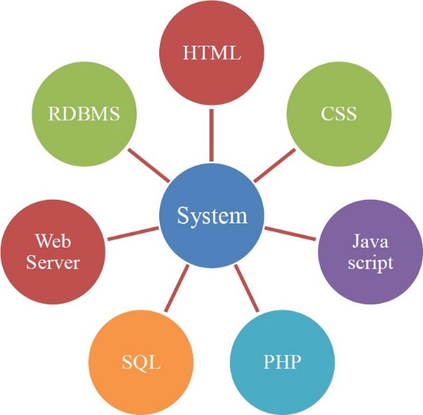

**CHAPTER 2**

**SYSTEM ANALYSIS AND DESIGN**

**2.1 SYSTEM ANALYSIS**

**SOFTWARE DEVELOPMENT LIFE CYCLE**

The software development life cycle can be defined as the process of developing generic software up to user satisfaction, generally the SDLC model or architecture involves following phases

* + 1. Requirement Analysis
    2. Design Analysis
    3. Implementation and coding
    4. Testing and Debugging
    5. Maintenance

## Requirement Analysis

In this process collection the data and information from different resources, stored at the centralized location.

## Design Analysis

At this phase designing the software includes data design and architecture design.

## Implementation and coding

This is the process of implementing a functional part of the product or project using appropriate programming language.

## Testing and Debugging

The software developed by using different software testing methods or tools. The main objective of this phase is to rectify the errors and debug them.

## Maintenance

It is also called as post installation phase. It involves maintenance of the developing tasks, but maintenance is very complicated task.

**THERE ARE FOUR SDLC MODELS**

They are:

* 1. Waterfall model
  2. Iterative enhancement model
  3. Bohemia’s spiral model
  4. Prototype model

**OUR PROJECT MAINLY BASED ON WATERFALL MODEL:**

System

Design

Maintenance

Testing

Implementation

Requirement

Analysis

Deployment

**2.2 SYSTEM PROCESS**

This Movie E-Ticketing portal is using PHP language as main develop language, it is a web application, therefore it will store in 1 folder and host by the web server application with Apache. The folder is name as movieticketingsystem and inside that folder containing different files. The different folder is containing the file with different function. The folder system is same as below:

**Movie E-Ticketing System:** Root folder contains

* **CSS:** This folder is containing the CSS file
* **Images:** This folder is containing the image used
* **Js:** This folder is used to store the entire JavaScript file to be use.
* **Log:** This folder is used to store the log file of the system.
* **Page:** This is used to store the PHP file which generating the content of each page
* **Src:** This folder is used to store the PHP file containing the PHP function used by the application.
* **Template:** This is used to store the template file of the system like header, footer and menu.
* **Widget:** This is used to store the PHP file call by the content PHP file.
* **Index.php:** This is the default page when the user visits the website.

**2.3 SYSTEM STUDY**

**EXISTING SYSTEM**

The present system is presently is an undeveloped form and the manual process of the overall system is too clumsy and complicated. The clients in the real time consultancy system can be too thick and may need many resources to be used upon the system. If the system is developed, in a distributed over interface with centralized database is the only solution.

**PROPOSED SYSTEM**

The Proposed System is the computerized version of the existing. It also provides easy and quick access over the data. It has authorization schemes. Backup data can be easily generated. The system maintains the different locations that are available and registered in the central database.

**2.4 ER DIAGRAM**

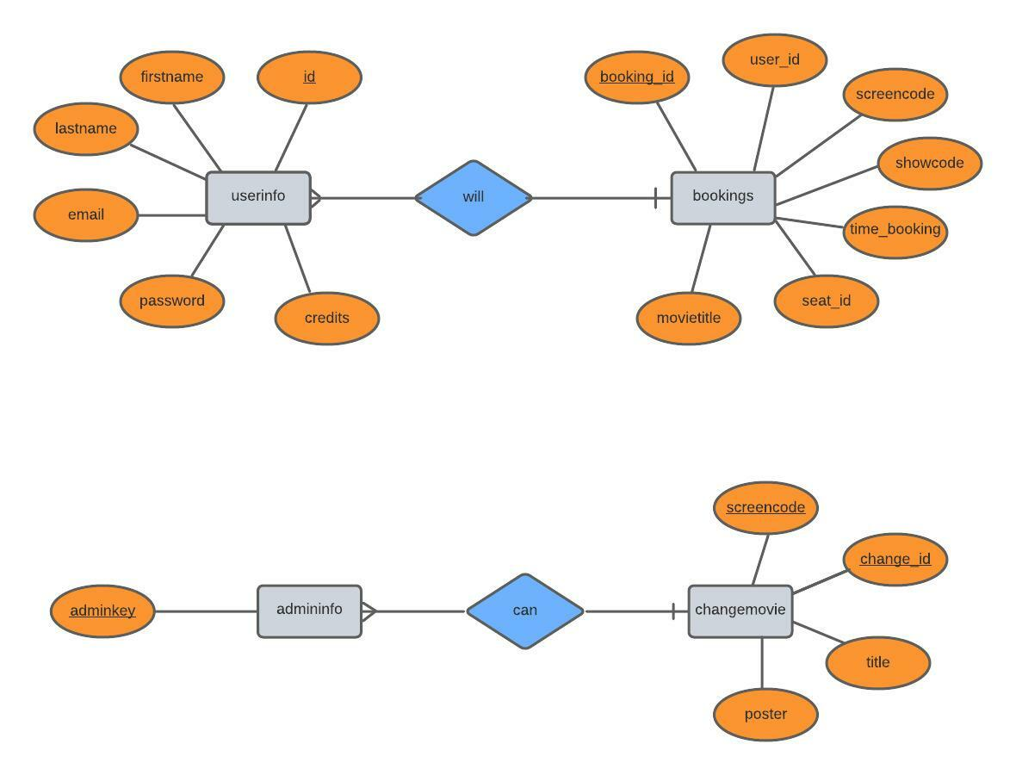

**2.5 SCHEMA DIAGRAM**

Userinfo

|  |  |  |  |  |  |
| --- | --- | --- | --- | --- | --- |
| id | Firstname | lastname | email | Password | Credits |

Bookings

|  |  |  |  |  |  |  |
| --- | --- | --- | --- | --- | --- | --- |
| booking_id | user_id | screencode | showcode | time_booking | seat_id | movietitle |

Changemovie

|  |  |  |  |
| --- | --- | --- | --- |
| screencode | change­_id | title | poster |

Admininfo

|  |
| --- |
| adminkey |

log

|  |  |  |  |
| --- | --- | --- | --- |
| id | firstname | lastname | timestamp |

**CHAPTER 3**

**SYSTEM SPECIFICATION**

**3.1 HARDWARE SPECIFICATION**

Processor Pentium: IV 3.0 GHz

Hard disk Drive: 10GB

RAM: 256Mb

**3.2 SOFTWARE SPECIFICATION**

Front End: HTML, CSS, Java Script, Bootstrap

Back End: PHP, MySQL Database

Operating System: XAMPP

**3.3 INPUT OUTPUT DEVICES**

Keyboard

Mouse

Monitor

**CHAPTER 4**

**IMPLEMENTATION**

**4.1 SCREENSHOTS**

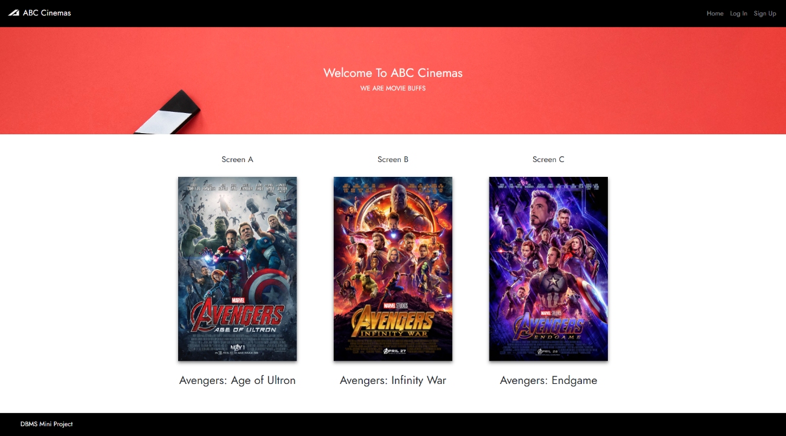

**4.1.1 HOME PAGE**

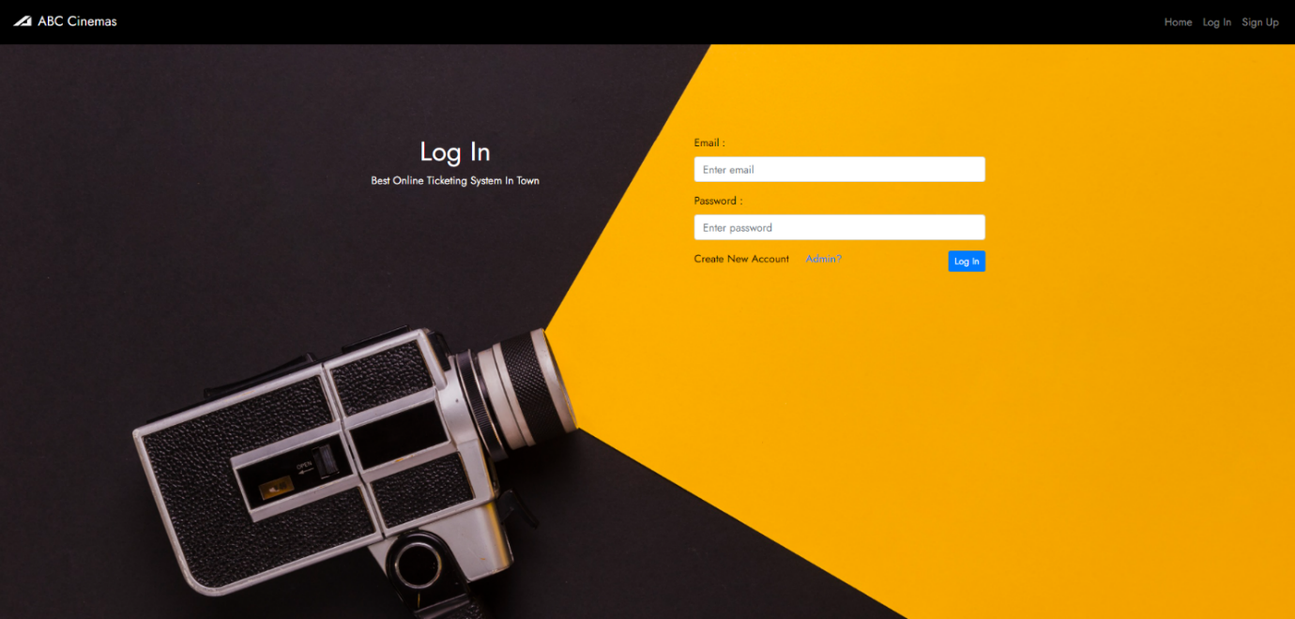

**4.1.2 USER LOGIN PAGE**

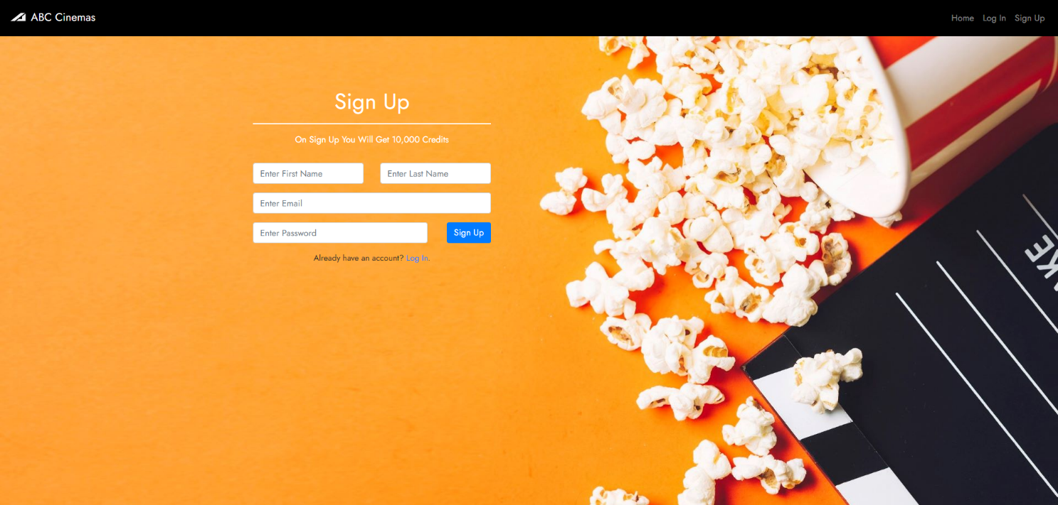

**4.1.3 SIGNUP PAGE**

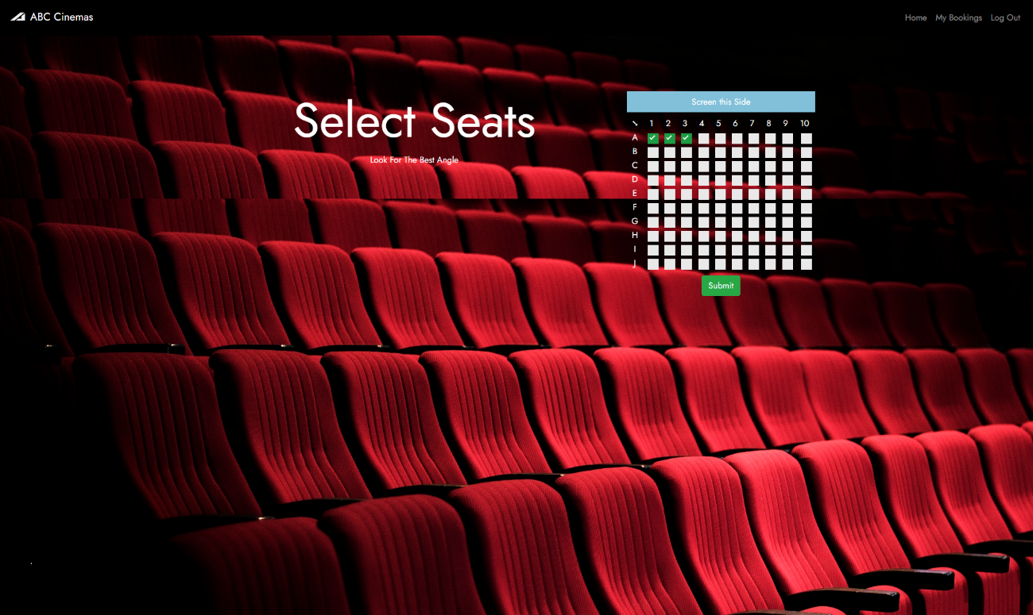

**4.1.4 SELECT SEAT**

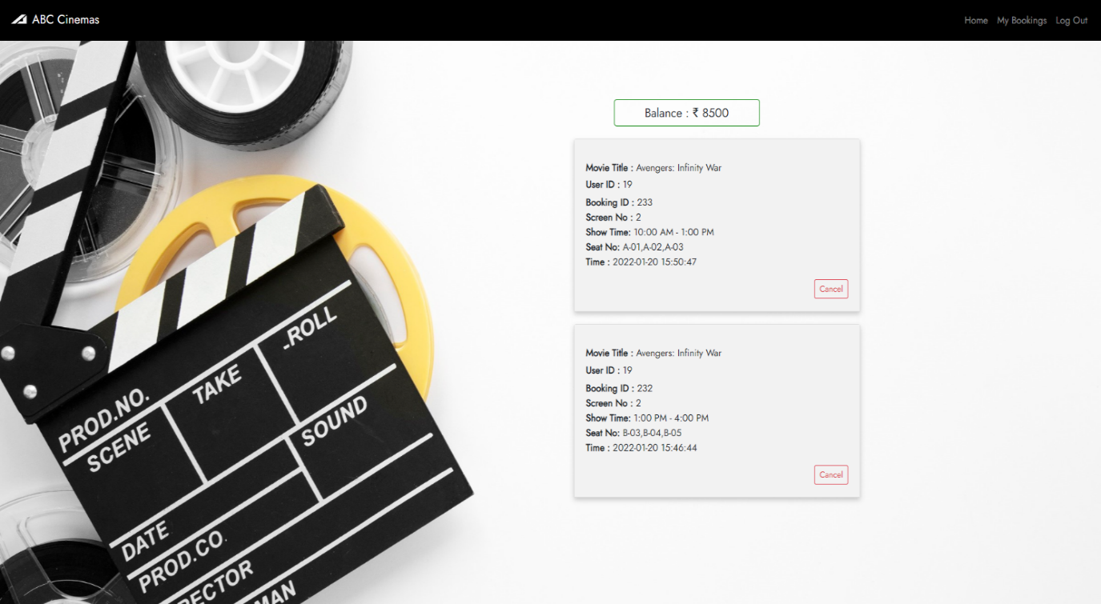

**4.1.5 BOOKING PAGE**

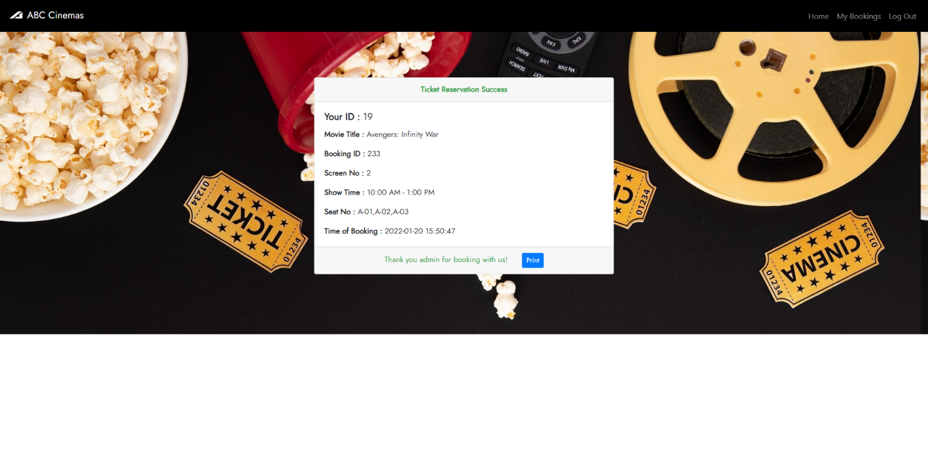

**4.1.6 CONFIRMATION PAGE**

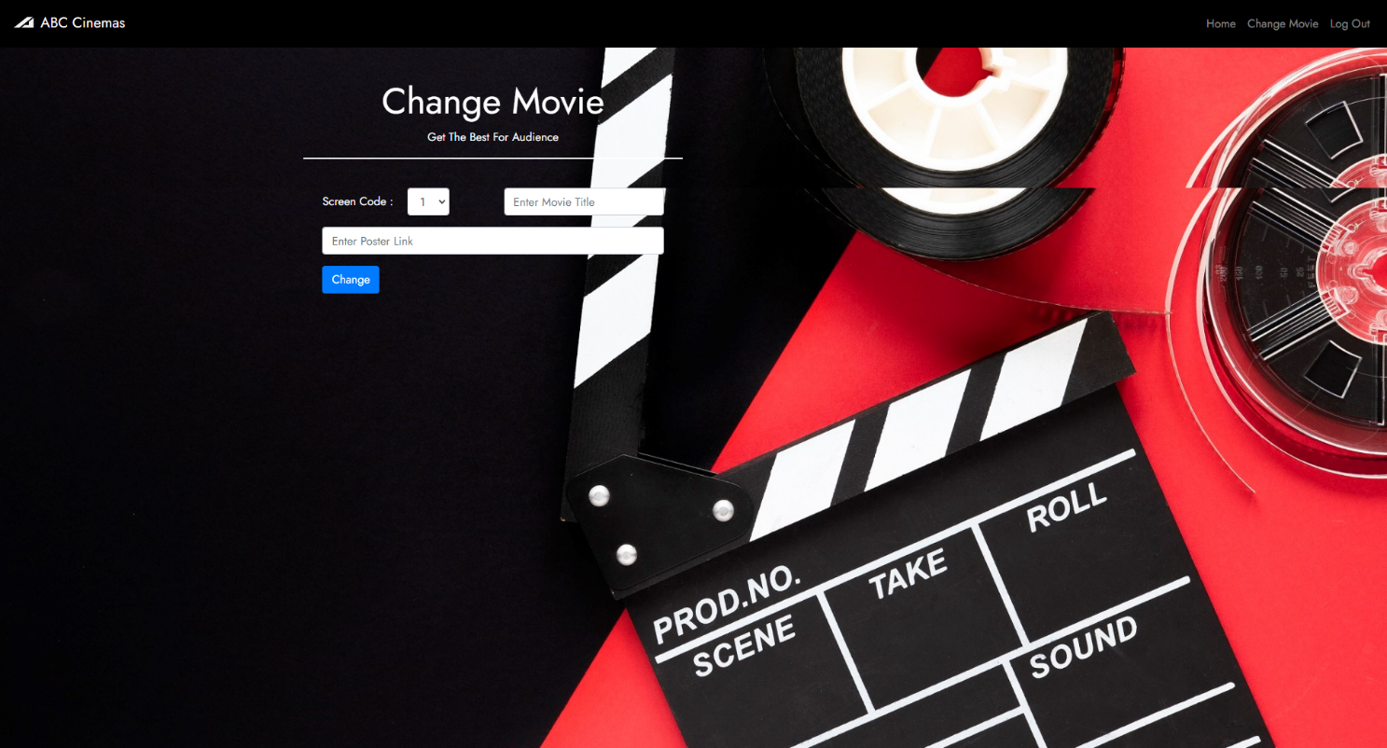

**4.1.7 MOVIE CHANGE**

**4.2 SAMPLE CODE**

<?php include('header.php'); ?>

<!-- Movie details  -->

<!-- Movie One  -->

<?php

include('connection.php');

$sql = "SELECT * FROM changemovie WHERE screencode=1";

$result = mysqli_query($conn, $sql);

$car = mysqli_fetch_array($result, MYSQLI_ASSOC);

$one_title = $car['title'];

$one_poster = $car['poster'];

//  Movie Two

$sql = "SELECT * FROM changemovie WHERE screencode=2";

$result = mysqli_query($conn, $sql);

$car = mysqli_fetch_array($result, MYSQLI_ASSOC);

$two_title = $car['title'];

$two_poster = $car['poster'];

// Movie Three

$sql = "SELECT * FROM changemovie WHERE screencode=3";

$result = mysqli_query($conn, $sql);

$car = mysqli_fetch_array($result, MYSQLI_ASSOC);

$three_title = $car['title'];

$three_poster = $car['poster'];

?>

<!-- setScreenCode  -->

<?php

if (isset($_POST['setScreenCode'])) {

$_SESSION['screen'] = $_POST['setScreenCode'];

$_SESSION['show'] = $_POST['radioShowCode'];

header('Location:select_seat.php');

}

?>

<?php

$welcomeName = '';

if (isset($_SESSION['user'])) {

$welcomeName = $_SESSION['user'];

}

?>

<!DOCTYPE html>

<html>

<title>Home</title>

<body style="font-family: 'Jost', sans-serif;">

<div class="text-center wel">

<h2 style="text-align: center; font-size: 30px; color: white;">Welcome <?php echo $welcomeName; ?> To ABC Cinemas</h2>

<medium style="color: white;">WE ARE MOVIE BUFFS</medium>

</div>

<!--Movie Posters-->

<div class="container">

<div class="row">

<!--Screen A-->

<div class="col-md-4">

<div class="poster_container text-center">

<h5>Screen A</h5x>

<div class="poster text-center" style="box-shadow: 0 4px 8px 0 rgba(0, 0, 0, 0.5);">

<img src="<?php echo $one_poster; ?>">

<div class="book">

<button type="button" class="btn btn-primary" data-toggle="modal" data-target="#showtime_a">Book</button>

</div>

</div>

<h3><?php echo $one_title; ?></h3>

</div>

</div>

<!--Screen B-->

<div class="col-md-4">

<div class="poster_container text-center">

<h5>Screen B</h5>

<div class="poster text-center" style="box-shadow: 0 4px 8px 0 rgba(0, 0, 0, 0.5);">

<img src="<?php echo $two_poster; ?>">

<div class="book">

<form method="POST" action="index.php">

<button type="button" class="btn btn-primary" data-toggle="modal" data-target="#showtime_b">Book</button>

</form>

</div>

</div>

<h3><?php echo $two_title; ?></h3>

</div>

<div class="more text-left">

<div id="more_s_b" class="collapse more_content text-justify">

<p><?php echo $two_more; ?></p>

</div>

</div>

</div>

<!--Screen C-->

<div class="col-md-4">

<div class="poster_container text-center">

<h5>Screen C</h5>

<div class="poster text-center" style="box-shadow: 0 4px 8px 0 rgba(0, 0, 0, 0.5);">

<img src="<?php echo $three_poster; ?>">

<div class="book">

<form method="POST" action="index.php">

<button type="button" class="btn btn-primary" data-toggle="modal" data-target="#showtime_c">Book</button>

</form>

</div>

</div>

<h3><?php echo $three_title; ?></h3>

</div>

<div class="more text-left">

<div id="more_s_c" class="collapse more_content text-justify">

<p><?php echo $three_more; ?></p>

</div>

</div>

</div>

</div>

</div>

<!-- Show Time Screen A -->

<div class="container">

<!-- The Modal -->

<div class="modal fade" id="showtime_a">

<div class="modal-dialog">

<div class="modal-content">

<!-- Modal Header -->

<div class="modal-header">

<h4 class="modal-title">Select Showtime</h4>

<button type="button" class="close" data-dismiss="modal">&times;</button>

</div>

<!-- Modal body -->

<div class="modal-body">

<form method="POST" action="index.php" id="showcode_a_form">

<table>

<tr>

<td><input type="radio" name="radioShowCode" value="1"> &nbsp;&nbsp;&nbsp;- Morning Show : 10:00 AM - 1:00 PM</td>

</tr>

<tr>

<td><input type="radio" name="radioShowCode" value="2"> &nbsp;&nbsp;&nbsp;- Noon Show : 1:00 PM - 4:00 PM</td>

</tr>

<tr>

<td><input type="radio" name="radioShowCode" value="3"> &nbsp;&nbsp;&nbsp;- Evening Show : 4:00 PM - 7: 00 PM</td>

</tr>

<tr>

<td><input type="hidden" name="setScreenCode" value="1"></td>

</tr>

</table>

</form>

</div>

<!-- Modal footer -->

<div class="modal-footer">

<input form="showcode_a_form" type="submit" class="btn btn-outline-success"></button>

</div>

</div>

</div>

</div>

</div>

<!-- Show Time Screen B  -->

<div class="container">

<!-- The Modal -->

<div class="modal fade" id="showtime_b">

<div class="modal-dialog">

<div class="modal-content">

<!-- Modal Header -->

<div class="modal-header">

<h4 class="modal-title">Select Showtime</h4>

<button type="button" class="close" data-dismiss="modal">&times;</button>

</div>

<!-- Modal body -->

<div class="modal-body">

<form method="POST" action="index.php" id="showcode_b_form">

<table>

<tr>

<td><input type="radio" name="radioShowCode" value="1"> &nbsp;&nbsp;&nbsp;- Morning Show : 10:00 AM - 1:00 PM</td>

</tr>

<tr>

<td><input type="radio" name="radioShowCode" value="2"> &nbsp;&nbsp;&nbsp;- Noon Show : 1:00 PM - 4:00 PM</td>

</tr>

<tr>

<td><input type="radio" name="radioShowCode" value="3"> &nbsp;&nbsp;&nbsp;- Evening Show : 4:00 PM - 7: 00 PM</td>

</tr>

<tr>

<td><input type="hidden" name="setScreenCode" value="2"></td>

</tr>

</table>

</form>

</div>

<!-- Modal footer -->

<div class="modal-footer">

<input form="showcode_b_form" type="submit" class="btn btn-outline-success"></button>

</div>

</div>

</div>

</div>

</div>

<!-- Show Time Screen C  -->

<div class="container">

<!-- The Modal -->

<div class="modal fade" id="showtime_c">

<div class="modal-dialog">

<div class="modal-content">

<!-- Modal Header -->

<div class="modal-header">

<h4 class="modal-title">Select Showtime</h4>

<button type="button" class="close" data-dismiss="modal">&times;</button>

</div>

<!-- Modal body -->

<div class="modal-body">

<form method="POST" action="index.php" id="showcode_c_form">

<table>

<tr>

<td><input type="radio" name="radioShowCode" value="1"> &nbsp;&nbsp;&nbsp;- Morning Show : 10:00 AM - 1:00 PM</td>

</tr>

<tr>

<td><input type="radio" name="radioShowCode" value="2"> &nbsp;&nbsp;&nbsp;- Noon Show : 1:00 PM - 4:00 PM</td>

</tr>

<tr>

<td><input type="radio" name="radioShowCode" value="3"> &nbsp;&nbsp;&nbsp;- Evening Show : 4:00 PM - 7: 00 PM</td>

</tr>

<tr>

<td><input type="hidden" name="setScreenCode" value="3"></td>

</tr>

</table>

</form>

</div>

<!-- Modal footer -->

<div class="modal-footer">

<input form="showcode_c_form" type="submit" class="btn btn-outline-success"></button>

</div>

</div>

</div>

</div>

</div>

<?php include('footer.php') ?>

</body>

</html>

**4.3 QUERIES**

**4.3.1 TABLE CREATION**

CREATE TABLE `bookings` (

  `screencode` int(11) NOT NULL,

  `showcode` int(11) NOT NULL,

  `booking_id` int(11) NOT NULL,

  `user_id` varchar(255) NOT NULL,

  `time_booking` varchar(255) NOT NULL DEFAULT current_timestamp(),

  `seat_id` varchar(255) NOT NULL,

  `movietitle` varchar(255) NOT NULL

);

CREATE TABLE `changemovie` (

`screencode` int(11) NOT NULL,

`title` varchar(255) NOT NULL,

`poster` varchar(255) NOT NULL,

`changeID` int(11) NOT NULL

);

CREATE TABLE `userinfo` (

`id` int(11) NOT NULL,

`firstName` varchar(255) NOT NULL,

`lastName` varchar(255) NOT NULL,

`email` varchar(255) NOT NULL,

`password` varchar(255) NOT NULL,

`credits` varchar(255) NOT NULL

);

CREATE TABLE `admin_info` (

`adminkey` varchar(255) NOT NULL

);

**4.3.2 SELECTING MOVIE ON EACH SCREEN**

"SELECT * FROM changemovie WHERE screencode=1";

"SELECT * FROM changemovie WHERE screencode=2";

"SELECT * FROM changemovie WHERE screencode=3";

**4.3.3 INSERTING USER DETAILS ON SIGN UP**

"INSERT INTO userinfo (firstName, lastName, email, password,credits)

VALUES ('$firstnameSign', '$lastnameSign', '$emailSign','$passwordSign','10000')";

**4.3.4 CHANGING MOVIE ON EACH SCREENS**

"UPDATE changemovie SET title='$title', poster='$poster' WHERE screencode=$screencode";

**4.4 TRIGGERS**

CREATE TRIGGER `log`

AFTER INSERT ON `userinfo`

FOR EACH ROW INSERT INTO logs

VALUES (NEW.id, NEW.firstname, New.lastname,NOW());

**4.5 STORED PROCEDURE**

CREATE DEFINER=`root`@`localhost` PROCEDURE `bookdetails`

(IN `bookid` INT)

SELECT movietitle,seat_id,time_booking,screencode,showcode

FROM bookings

WHERE booking_id = bookid$$;

**CHAPTER 5**

**TESTING**

Testing is an investigation conducted to provide shareholder with the information about the quality of the product or service under test. Software testing can also provide an objective, independent view of the software to allow the business to appreciate and understand the risk of the software implementation. Test techniques include, but are not limited to the process of executing a program or application with the intent of finding software errors or other defects. Software testing can be started as process of validating and verifying that a computer program/application/product:

* + - Meets the requirements that guides its design and development.
    - Works as expected.
    - Can be implemented with the same characteristics.

**5.1 UNIT TESTING**

Unit testing also known as component testing refer to tests that verify the functionality of a specific section of code, usually at the function level. In a project-oriented environment, this is usually at the usually at the class level, and the minimal unit tests include the construction and destructors. These types of tests are usually written by developers as they work on code to ensure the specific function is working as expected. One function might have multiple tests, to catch to corner cases or the other branches in the code. Unit testing cannot verify the functionality of a piece of a software, but rather is used to assure that the building block, the software uses work independently of each other. Unit testing is a software development process that involves synchronized application of a board spectrum of defect prevention and detection strategies to reduce the software development risk, time and cost. It is performed by the software developer or engineer during the construction phase of the software development.

**5.2 INTEGRATION TESTING**

Integration testing is any type of software testing that seeks to verify the interfaces between components against the software design. Software components may be integrated in an iterative way or altogether. Normally the former is considered a better practice since it allows interface issues to be located more quickly and fixed. Integration testing works to expose defects in the interfaces and interaction between integrated components corresponding to elements of the architectural design are integrated tested until the software works as a system.

**5.3 PERFORMANCE TESTING**

Term often used interchangeably with stresses and load testing. To check whether the system meets performance requirements using different performance and load tools performance testing is done.

**5.4 VALIDATION TESTING**

Validation checks that the products design satisfies or fits the intended is i.e., the software meets the user requirements. This is done through dynamic testing and other forms of review. Verification and validation is not the same thing. All though they often confused. The difference between them is: Validation: The process of evaluating software during or at the end of the development process to determine whether it satisfiers specific requirements. Verification: The process of evaluating software to determine whether the products of a given development phase satisfy the condition imposed at the start of that phase. In other words, Validation ensures that the product actually meets the user’s needs and that the specification were correct in the first place, while verification is ensuring that the product has been built according to the requirements and design specification. Validation ensures that you built the right thing; verification ensures that you built it right; Validation confirms that the product, as provided, will fulfill its intended use.

**CHAPTER 6**

**CONCLUSION AND FUTURE ENHANCEMENT**

**6.1 CONCULSION**

It has been a great pleasure for me to work on this extracting and challenging project. This project provided us practical knowledge of creating software which is programmed in php using file structure concept. And about all handling procedure related with hotel Management system. It also provides Knowledge about the latest technology used in developing. File structure concepts that will be a great demand in the future. This will provide better opportunities and guidance in the future in developing projects independently. Currently, the Movie E-Ticketing system is to enhance and update the existing system by increasing its efficiency and effectiveness. The software improves the working methods by replacing the existing manual system with the computer-based system.

**6.2 FUTURE ENHANCEMENT**

Everything that is made has some or the other things to be added to make it better than revolutions. The project “Movie E-Ticket System”, it has been tried to develop a robust and fault free system, still enough flexibility has been provided for further enhancements and modifications. As I mentioned earlier then the designed forms are typically reflections of the developer, so I strongly believe that the enhancement to be done with the project to be done with the design changes, coding changes. But at the same time. I would like to mention that since one cannot claim himself as a master of the technology there is always some scope of technical modifications in the project that may lead to find code redundancy &storage space minimization. Since the data is retrieved from the tables where everything is based on the coding system if the coding system is changed then the system needs to be redesigned

**CHAPTER 7**

**REFERENCES**

1. <https://phpgurukul.com>

2. www.youtube.com

3. <https://github.com>

4. <https://www.w3schools.com>